
Research Report: Claim & Save
Feb 2024| DRI: Kelly Peterson Working Team: Claudia Ng Ishaan KansalShikha Khinvasara Research Brief

| Business Context:
The next iteration of affordability experiments to win back churned Cx and increase OR among OCCx includes Claim to Save. Claim to Save includes the affordability aspects of Nearby, the agency of Star and Save, and the selection and urgency of Weekly Drops. This new approach is hoping to ensure that Cx awareness and engagement with the offer is crystal clear and memorable, encouraging Cx to make DoorDash more of a habit.

| Research Approach: We conducted 30 min 1:1 interviews with 6 Classic Cx.

| TLDR

The final adjusted prototype seen here is the recommended approach to Claim & Save for Cx. Cx found this clear and motivating. For most the experience of claiming and receiving a validation that discount will be applied at checkout was delightful. Cx who had previous experience with DashPass recognizing the similar savings. Some Cx mentioned that if they get used to the savings, it may make them more open to signing up for DashPass.

| Insights & Recommendations
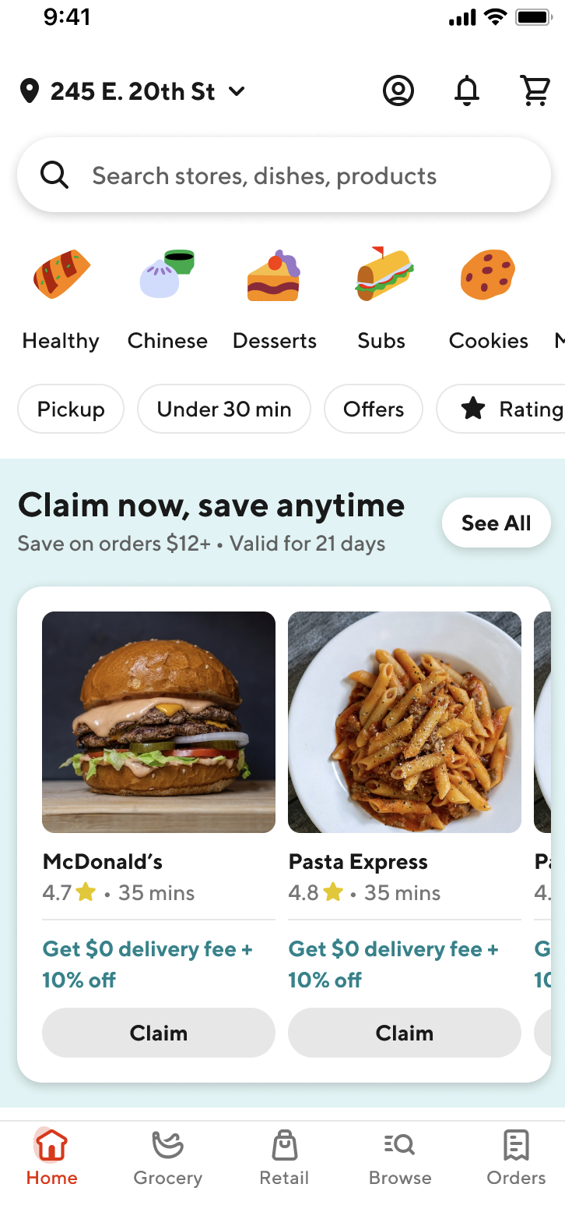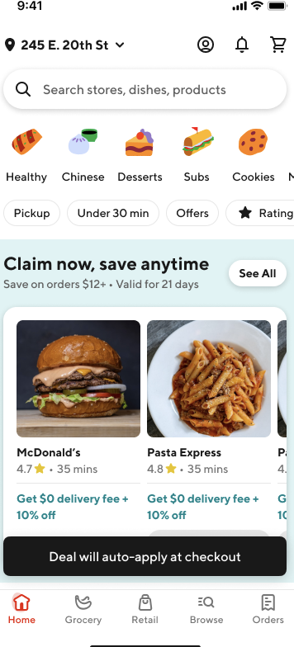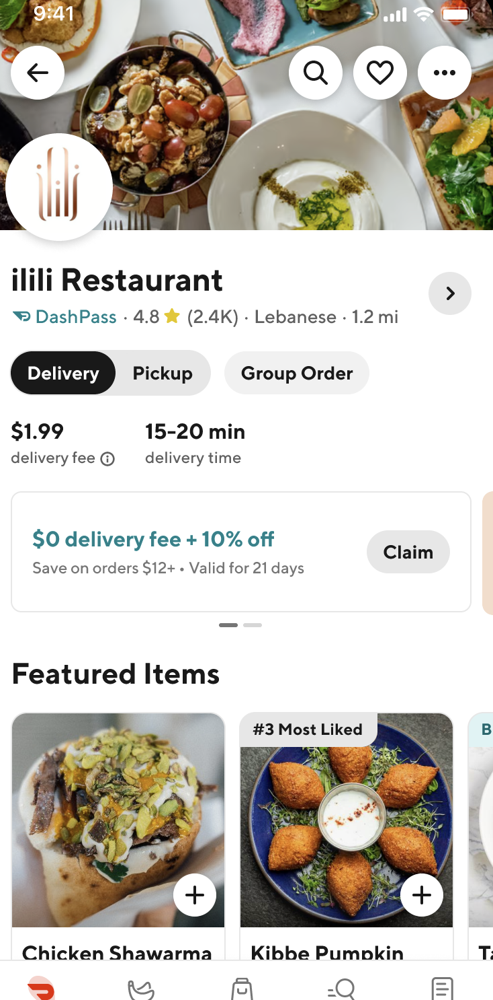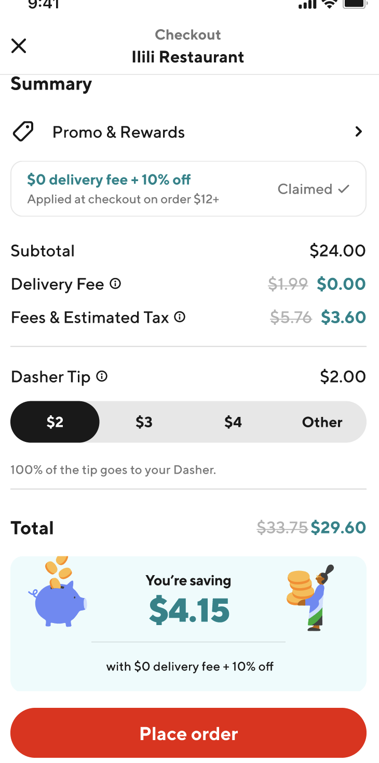

Excitement Would make me want to order more | - Almost all Cx interviewed indicated that the savings experience was a good deal that would have the potential to make them order more frequently  - Most Cx found the experience of “clipping a coupon” delightful.  - Half of Cx really liked claiming and equate it to coupon clipping  - Most Cx felt excited about the savings highlighted on the checkout screen | If you already know that you're going to save that money, you're going to go to that app. You're going to want to go to DoorDash over Uber Eats…So if I know I'm going to save even more money with DoorDash, I'm definitely going to go to DoorDash.
Cognition  Very Easy to Use | - Every Cx interviewed understood claiming on the homepage  - They knew what the deal was, what the limitation was ($12) and that they needed to click to claim that deal  - One Cx felt like it was something we should just do but isn't majorly bothered by it  - Cx understood claiming on the store page; Cx indicated that they would not need to see the homepage to notice & understand claiming on the store page. Experimentation will need to validate this.  - The pop up text saying "deal will be auto applied" was also validating for Cx that they had in fact claimed a deal and would receive the discount  - All Cx were also very happy with the checkout screen, they felt it was clear that the promotion was applied and liked seeing the summary of savings  - The only area of confusion for Cx was around limitations around claiming. It wasn’t clear to them if they had to order right after claiming or if it remains consistent.  - Once we changed the carousel header and description to the recommended experience linked above this issue was resolved. | I don't like feeling pressured to do something, but clicking it myself and doing it, that's not pressuring me, that's giving me an option.  I liked that it was super easy and self explanatory. I mean, you know, just click the button.
Impact on DashPass: Mixed Reactions | - Cx are mixed in their reactions to DashPass depending on their previous experiences with DashPass  - Those that had it previously recognize that it is similar savings and think that it provides value  - Those that have not tried DashPass previously think the saving are similar but are not sure  - 2 respondents thought the Claim & Save savings were higher than DashPass because they did not know about the 10% off for DashPass  - For the most part Cx separate these savings and the value of DashPass depending on how much they order (or perceive they order) takeout  - Overall reactions to DashPass were similar to those we typically see of Classic Cx  - Some were interested in the future  - Some were just not willing to commit themselves mentally (“we lie to ourselves and say we’re gonna be better about ordering out”)  - Some just could not afford the additional subscription based on their experience | Like when I was using it almost every day, I had DashPass. But once I wasn't working every day, I canceled my subscription to DashPass. But that's only because it was maybe once a week, twice a week, instead of four or five days a week.  I know you get the free delivery, which is typical of DashPass, and then usually you save some percentage off of like the fees that come with it, and then this maybe adds a little bit more value because it was also taking some portion off of your actual order as well, which I don't think in most cases DashPass does unless there's a special deal running. So I would say it seems pretty comparable and maybe would be a good alternative for folks who maybe don't want to have that subscription.

